The following method is adopted to make the left and right eyes display content separately.

1. Drag SteamVR "CameraRig" prefab onto the scene.
2. Create two empty game objects, named CamLeft and CamRight, and set them at the same coordinates.
3. Add a SteamVR_Camera script component to each.
4. In the inspector, on the "SteamVR_Camera" component you just added, click the "Expand" button.
5. Create two new layers: "Left" and "Right"
6. In the inspector, set Target Eye: Left, and untick "Right" in Culling Mask. CamRight in the same way.

This is a screenshot of setting up in unity：

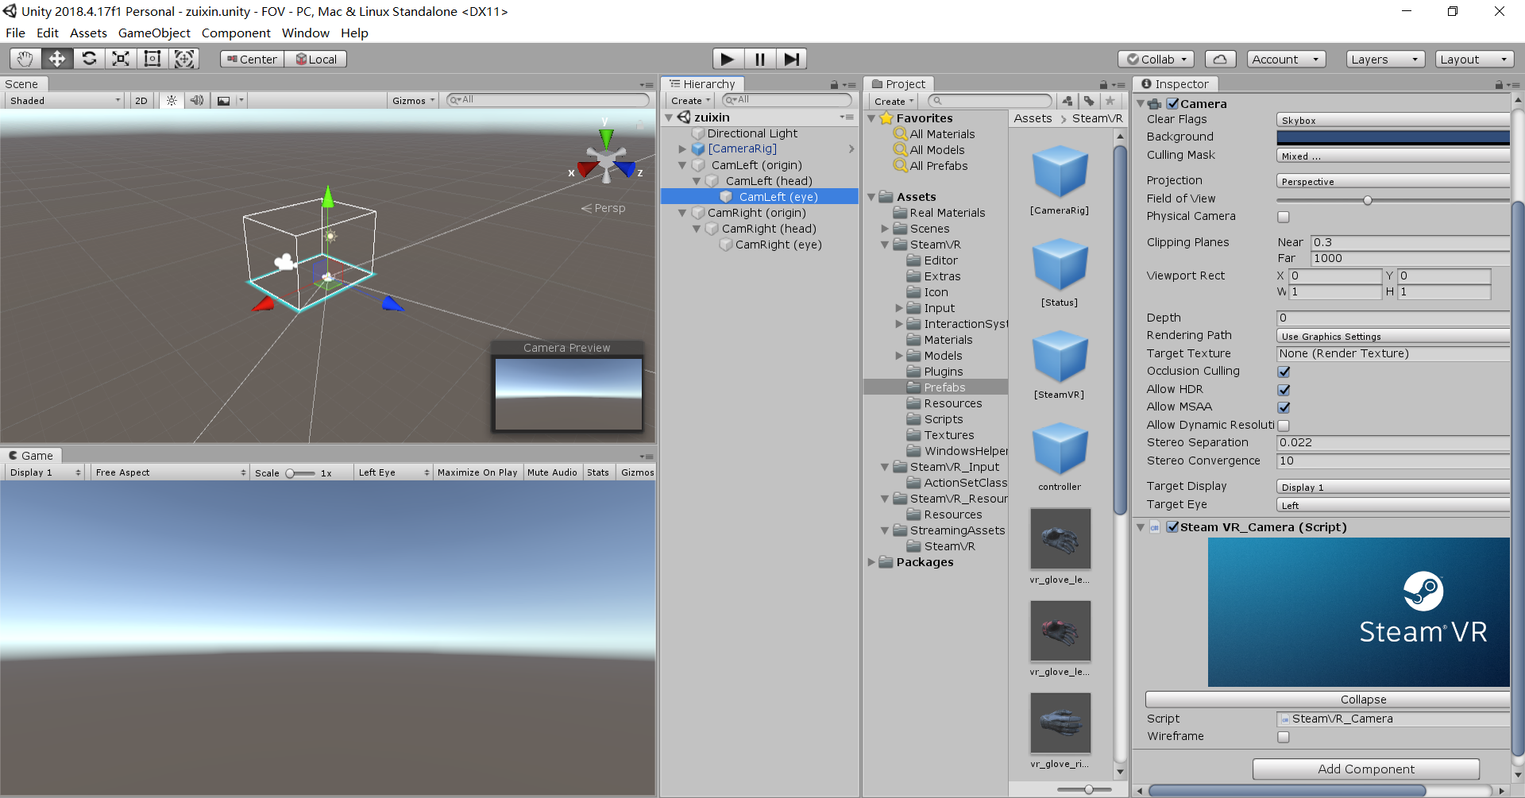

Finished displaying the content of left and right eyes separately. Next we are going to study how to render the left and right eyes separately.

<https://github.com/ViveSoftware/ViveFoveatedRendering/blob/master/UnityPackage/ViveFoveatedRendering/Editor/ViveFoveatedRendering_Editor.cs>